Returns

|  |  |  |  |  |  |  |  |  |  |  |  |
| --- | --- | --- | --- | --- | --- | --- | --- | --- | --- | --- | --- |
| *Index* | *Abbreviation* | *ISIN Identifier* | *Mnemonic* | *Region* | *Data Available for Index* | | *Data Available for Stocks* | | | *Period Analysed* | |
| ***Start*** | ***End*** | ***Start*** | ***End*** | ***#Stocks per month*** | ***Start*** | ***End*** |
| ***Amsterdam Exchange Index*** | AEX | NL0000000107 | AMSTEOE | Netherlands | 1/01/1983  (3/01/1983) | 31/12/2022  (30/12/2022) | 0402 | 1023 | 25 | April 2002 | Dec 2022 |
| ***BEL 20 Index*** | BEL20 | BE0389555039 | BGBEL20 | Belgium | 2/01/1991 | 31/12/2022  (30/12/2022) | 0702 | 1023 | 20 | July 2002 | Dec 2022 |
| ***Cotation Assistée en Continu 40*** | CAC40 | FR0003500008 | FRCAC40 | France | 31/12/1987 | 31/12/2022  (30/12/2022) | 0700 | 1023 | 40 | July 2000 | Dec 2022 |
| ***Deutscher Aktienindex*** | DAX | DE0008469008 | DAXINDX | Germany | 31/12/1964 | 31/12/2022  (30/12/2022) | 0700 | 1023 | 40 | July 2000 | Dec 2022 |
| ***Euro Overnight Index Average*** | EONIA | EU0009659945 | EUEONIA | Eurozone | 1/12/2000 | 31/10/2019 | Not applicable. | | | Jan 2002 | Feb 2024 |
| ***Euro short-term rate*** | €STR | EU000A2X2A25 | EURSTR | Eurozone | 1/11/2019 | 29/03/2024 |
| ***OMX Stockholm 30 Index*** | OMX30 | SE0000337842 | SWEDOMX | Sweden | 2/01/2002 | 31/12/2022  (30/12/2022) | 0704 | 1023 | 30 | July 2004 | Dec 2022 |
| ***STOXX Europe 50*** | SX5P | EU0009658160 | DJE5501 | Europe |  |  | Not applicable. | | | Jan 2002 | Feb 2024 |
| ***STOXX Europe 600*** | SXXP | EU0009658202 | DJSTOXX | Europe | 29/12/2000 | 29/02/2024 | 0102 | 0324 | 600 | Jan 2002 | Feb 2024 |
| ***Swiss Market Index*** | SMI | CH0009980894 | SWISSMI | Switzerland | 30/04/1993 | 31/12/2022  (30/12/2022) | 0701 | 1023 | 20 | July 2001 | Dec 2022 |

Data Definition of DataStream Data:

Daily Return (in 1 year prior) – Stocks and Index

Variables that use this data:

**From these daily returns, weekly aggregates have been calculated and these have been used for variables indicated with an asterix.**

For Index:

* **Comove as an Unexplained Return Premium, Main Results: Comove*, and Beta.**
* **Comove as an Unexplained Return Premium, Robustness Tests, Alternative Factor Measures: Comove*, and Beta.**
* **Comove as an Unexplained Return Premium, Robustness Tests, Alternative Portfolio Aggregation: Comove*, and Beta.**
* **Comove as an Unexplained Return Premium, Robustness Tests, Controlling for Fama and MacBeth regressions, Main variables: Comove*, and Beta.**
* **Comove as an Unexplained Return Premium, Robustness Tests, Controlling for Fama and MacBeth regressions, Other Measurements of Dependency and Volatility: Downside beta, Upside beta, Lower tail dependence, Upper tail dependence, and Idiosyncratic Volatility.**
* **Comove as an Unexplained Return Premium, Robustness Tests, Controlling for Fama and MacBeth regressions, other benchmarks, fixed effects and skipped month: Comove with adjusted period*.**

**For Stocks:**

* **Comove as an Unexplained Return Premium, Main Results: Comove*, Beta, and Return.**
* **Comove as an Unexplained Return Premium, Robustness Tests, Alternative Factor Measures: Comove*, Beta, Market Premium, and Return.**
* **Comove as an Unexplained Return Premium, Robustness Tests, Alternative Portfolio Aggregation: Comove*, Beta, and Return.**
* **Comove as an Unexplained Return Premium, Robustness Tests, Controlling for Fama and MacBeth regressions, Main variables: Comove*, Beta, Momentum, and Return.**
* **Comove as an Unexplained Return Premium, Robustness Tests, Controlling for Fama and MacBeth regressions, Other Measurements of Dependency and Volatility: Downside beta, Upside beta, Lower tail dependence, Upper tail dependence, Idiosyncratic Volatility, Minimum Return, Maximum Return, and Illiquidity Ratio.**
* **Comove as an Unexplained Return Premium, Robustness Tests, Controlling for Fama and MacBeth regressions, other benchmarks, fixed effects and skipped month: Short-term momentum, Medium-term momentum, and Comove with adjusted period*.**

Datatype: X(RI)~E

Command:

For Index: = DSGRID("DJSTOXX";"RI";"1999-01-01";"2024-03-31";"D;"RowHeader=true;ColHeader=true;Heading=true;Curn=true;DispSeriesDescription=true;YearlyTSFormat=false;QuarterlyTSFormat=false;MonthlyTSFormat=False";"")

For Stocks: = DSGRID.(“LDJSTOXXMMYY”, “X(RI)~E”, “startDate”, “endDate”, “D”, "RowHeader=true;TimeSeriesList=true;ColHeader=true;Transpose=true;DispSeriesDescription=false;YearlyTSFormat=false;QuarterlyTSFormat=false;Clearself=y;MonthlyTSFormat=True”)

* With MMYY the first month of each quarter, with the months ranging from 0102 until 0324.
* With startDate and endDate in YYYY-MM-DD format; startDate the first day of the year prior to MMYY and endDate the last day of two months after the MMYY. For example, for Jan 2002, 2001-01-01 and 2002-03-31.

Definition: This is the theoretical absolute growth in value of a share holding over that day, assuming that dividends are re-invested to purchase additional unites of the stock at the closing price applicable on the ex-dividend date. Note that these “prices” are converted to euro.

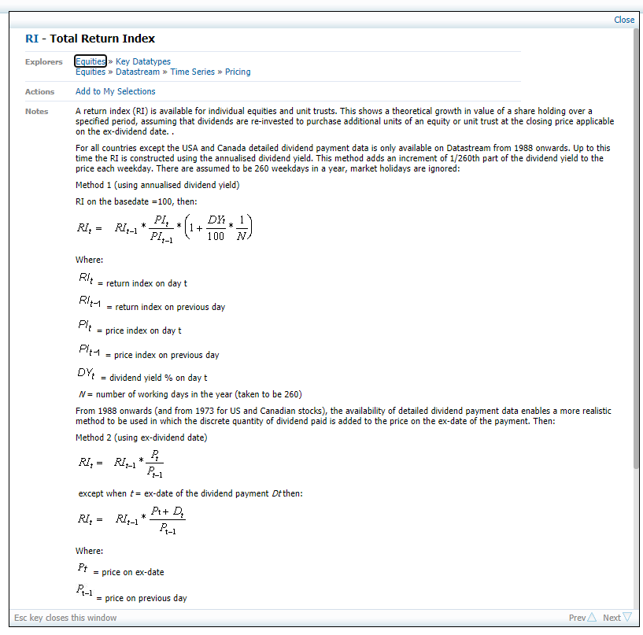

Data Definition of DataStream Data:

Daily Return (in 1 year prior) – Risk-free Index

Variables that use this data:

**From these daily returns, weekly aggregates have been calculated and these have been used for variables indicated with an asterix.**

For Index:

* **Comove as an Unexplained Return Premium, Robustness Tests, Alternative Factor Measures: Market Premium.**

Datatype: X(RI)~E

Command:

**Because of the replacement of the EONIA by the Euro Short-term rate, two different indexes were employed.**

For Index:

DSGRID("DJES50I";"RI";"2000-12-01";"31-10-2019";"D";"RowHeader=true;ColHeader=true;Heading=true;Curn=true;DispSeriesDescription=true;YearlyTSFormat=false;QuarterlyTSFormat=false;MonthlyTSFormat=False";"")

= DSGRID("EUROSTR";"RI";"2019-11-01";"2024-03-31";"D";"RowHeader=true;ColHeader=true;Heading=true;Curn=true;DispSeriesDescription=true;YearlyTSFormat=false;QuarterlyTSFormat=false;MonthlyTSFormat=False";"")

Definition: This is the theoretical absolute growth in value of a share holding over that day, assuming that dividends are re-invested to purchase additional unites of the stock at the closing price applicable on the ex-dividend date. Note that these “prices” are converted to euro.



Data Definition of DataStream Data:

Daily Return (in 1 year prior) – Amsterdam Exchange Stocks and Index

Variables that use this data:

**From these daily returns, weekly aggregates have been calculated and these have been used for variables indicated with an asterix.**

For Index:

* **Comove as an Unexplained Return Premium, Robustness Tests, Alternative Indexes: Comove*, and Beta.**

**For Stocks:**

* **Comove as an Unexplained Return Premium, Robustness Tests, Alternative Indexes: Comove*, Beta and Return.**

Datatype: X(RI)~E

Command:

For Index: = DSGRID("AMSTEOE";"RI";"31-03-2001";"2022-12-31";"D;"RowHeader=true;ColHeader=true;Heading=true;Curn=true;DispSeriesDescription=true;YearlyTSFormat=false;QuarterlyTSFormat=false;MonthlyTSFormat=False";"")

For Stocks: = DSGRID.(“LAMSTEOEMMYY”, “X(RI)~E”, “startDate”, “endDate”, “D”, "RowHeader=true;TimeSeriesList=true;ColHeader=true;Transpose=true;DispSeriesDescription=false;YearlyTSFormat=false;QuarterlyTSFormat=false;Clearself=y;MonthlyTSFormat=True”)

* With MMYY the first month of each quarter, with the months ranging from 0402 until 1022.
* With startDate and endDate in YYYY-MM-DD format; startDate the first day of the year prior to MMYY and endDate the last day of two months after the MMYY. For example, for Jan 2002, 2001-01-01 and 2002-03-31.

Definition: This is the theoretical absolute growth in value of a share holding over that day, assuming that dividends are re-invested to purchase additional unites of the stock at the closing price applicable on the ex-dividend date. Note that these “prices” are converted to euro.



Data Definition of DataStream Data:

Daily Return (in 1 year prior) –BEL 20 Stocks and Index

Variables that use this data:

**From these daily returns, weekly aggregates have been calculated and these have been used for variables indicated with an asterix.**

For Index:

* **Comove as an Unexplained Return Premium, Robustness Tests, Alternative Indexes: Comove*, and Beta.**

**For Stocks:**

* **Comove as an Unexplained Return Premium, Robustness Tests, Alternative Indexes: Comove*, Beta and Return.**

Datatype: X(RI)~E

Command:

For Index: = DSGRID("BGBEL20";"RI";"31-06-2001";"2022-12-31";"D;"RowHeader=true;ColHeader=true;Heading=true;Curn=true;DispSeriesDescription=true;YearlyTSFormat=false;QuarterlyTSFormat=false;MonthlyTSFormat=False";"")

For Stocks: = DSGRID.(“LBGBEL20MMYY”, “X(RI)~E”, “startDate”, “endDate”, “D”, "RowHeader=true;TimeSeriesList=true;ColHeader=true;Transpose=true;DispSeriesDescription=false;YearlyTSFormat=false;QuarterlyTSFormat=false;Clearself=y;MonthlyTSFormat=True”)

* With MMYY the first month of each quarter, with the months ranging from 0702 until 1022.
* With startDate and endDate in YYYY-MM-DD format; startDate the first day of the year prior to MMYY and endDate the last day of two months after the MMYY. For example, for Jan 2002, 2001-01-01 and 2002-03-31.

Definition: This is the theoretical absolute growth in value of a share holding over that day, assuming that dividends are re-invested to purchase additional unites of the stock at the closing price applicable on the ex-dividend date. Note that these “prices” are converted to euro.



Data Definition of DataStream Data:

Daily Return (in 1 year prior) – CAC 40 Stocks and Index

Variables that use this data:

**From these daily returns, weekly aggregates have been calculated and these have been used for variables indicated with an asterix.**

For Index:

* **Comove as an Unexplained Return Premium, Robustness Tests, Alternative Indexes: Comove*, and Beta.**

**For Stocks:**

* **Comove as an Unexplained Return Premium, Robustness Tests, Alternative Indexes: Comove*, Beta and Return.**

Datatype: X(RI)~E

Command:

For Index: = DSGRID("FRCAC40";"RI";"31-06-1999";"2022-12-31";"D;"RowHeader=true;ColHeader=true;Heading=true;Curn=true;DispSeriesDescription=true;YearlyTSFormat=false;QuarterlyTSFormat=false;MonthlyTSFormat=False";"")

For Stocks: = DSGRID.(“LFRCAC40MMYY”, “X(RI)~E”, “startDate”, “endDate”, “D”, "RowHeader=true;TimeSeriesList=true;ColHeader=true;Transpose=true;DispSeriesDescription=false;YearlyTSFormat=false;QuarterlyTSFormat=false;Clearself=y;MonthlyTSFormat=True”)

* With MMYY the first month of each quarter, with the months ranging from 0700 until 1022.
* With startDate and endDate in YYYY-MM-DD format; startDate the first day of the year prior to MMYY and endDate the last day of two months after the MMYY. For example, for Jan 2002, 2001-01-01 and 2002-03-31.

Definition: This is the theoretical absolute growth in value of a share holding over that day, assuming that dividends are re-invested to purchase additional unites of the stock at the closing price applicable on the ex-dividend date. Note that these “prices” are converted to euro.



Data Definition of DataStream Data:

Daily Return (in 1 year prior) – DAX Stocks and Index

Variables that use this data:

**From these daily returns, weekly aggregates have been calculated and these have been used for variables indicated with an asterix.**

For Index:

* **Comove as an Unexplained Return Premium, Robustness Tests, Alternative Indexes: Comove*, and Beta.**

**For Stocks:**

* **Comove as an Unexplained Return Premium, Robustness Tests, Alternative Indexes: Comove*, Beta and Return.**

Datatype: X(RI)~E

Command:

For Index: = DSGRID("DAXINDX";"RI";"31-06-1999";"2022-12-31";"D;"RowHeader=true;ColHeader=true;Heading=true;Curn=true;DispSeriesDescription=true;YearlyTSFormat=false;QuarterlyTSFormat=false;MonthlyTSFormat=False";"")

For Stocks: = DSGRID.(“LDAXINDXMMYY”, “X(RI)~E”, “startDate”, “endDate”, “D”, "RowHeader=true;TimeSeriesList=true;ColHeader=true;Transpose=true;DispSeriesDescription=false;YearlyTSFormat=false;QuarterlyTSFormat=false;Clearself=y;MonthlyTSFormat=True”)

* With MMYY the first month of each quarter, with the months ranging from 0700 until 1022.
* With startDate and endDate in YYYY-MM-DD format; startDate the first day of the year prior to MMYY and endDate the last day of two months after the MMYY. For example, for Jan 2002, 2001-01-01 and 2002-03-31.

Definition: This is the theoretical absolute growth in value of a share holding over that day, assuming that dividends are re-invested to purchase additional unites of the stock at the closing price applicable on the ex-dividend date. Note that these “prices” are converted to euro.



Data Definition of DataStream Data:

Daily Return (in 1 year prior) –OMX Stocks and Index

Variables that use this data:

**From these daily returns, weekly aggregates have been calculated and these have been used for variables indicated with an asterix.**

For Index:

* **Comove as an Unexplained Return Premium, Robustness Tests, Alternative Indexes: Comove*, and Beta.**

**For Stocks:**

* **Comove as an Unexplained Return Premium, Robustness Tests, Alternative Indexes: Comove*, Beta and Return.**

Datatype: X(RI)~E

Command:

For Index: = DSGRID("SWEDOMX";"RI";"31-06-2003";"2022-12-31";"D;"RowHeader=true;ColHeader=true;Heading=true;Curn=true;DispSeriesDescription=true;YearlyTSFormat=false;QuarterlyTSFormat=false;MonthlyTSFormat=False";"")

For Stocks: = DSGRID.(“LSWEDOMXMMYY”, “X(RI)~E”, “startDate”, “endDate”, “D”, "RowHeader=true;TimeSeriesList=true;ColHeader=true;Transpose=true;DispSeriesDescription=false;YearlyTSFormat=false;QuarterlyTSFormat=false;Clearself=y;MonthlyTSFormat=True”)

* With MMYY the first month of each quarter, with the months ranging from 0704 until 1022.
* With startDate and endDate in YYYY-MM-DD format; startDate the first day of the year prior to MMYY and endDate the last day of two months after the MMYY. For example, for Jan 2002, 2001-01-01 and 2002-03-31.

Definition: This is the theoretical absolute growth in value of a share holding over that day, assuming that dividends are re-invested to purchase additional unites of the stock at the closing price applicable on the ex-dividend date. Note that these “prices” are converted to euro.



Data Definition of DataStream Data:

Daily Return (in 1 year prior) –SMI Stocks and Index

Variables that use this data:

**From these daily returns, weekly aggregates have been calculated and these have been used for variables indicated with an asterix.**

For Index:

* **Comove as an Unexplained Return Premium, Robustness Tests, Alternative Indexes: Comove*, and Beta.**

**For Stocks:**

* **Comove as an Unexplained Return Premium, Robustness Tests, Alternative Indexes: Comove*, Beta and Return.**

Datatype: X(RI)~E

Command:

For Index: = DSGRID("SWISSMI";"RI";"31-06-2000";"2022-12-31";"D;"RowHeader=true;ColHeader=true;Heading=true;Curn=true;DispSeriesDescription=true;YearlyTSFormat=false;QuarterlyTSFormat=false;MonthlyTSFormat=False";"")

For Stocks: = DSGRID.(“LSWISSMIMMYY”, “X(RI)~E”, “startDate”, “endDate”, “D”, "RowHeader=true;TimeSeriesList=true;ColHeader=true;Transpose=true;DispSeriesDescription=false;YearlyTSFormat=false;QuarterlyTSFormat=false;Clearself=y;MonthlyTSFormat=True”)

* With MMYY the first month of each quarter, with the months ranging from 0701 until 1022.
* With startDate and endDate in YYYY-MM-DD format; startDate the first day of the year prior to MMYY and endDate the last day of two months after the MMYY. For example, for Jan 2002, 2001-01-01 and 2002-03-31.

Definition: This is the theoretical absolute growth in value of a share holding over that day, assuming that dividends are re-invested to purchase additional unites of the stock at the closing price applicable on the ex-dividend date. Note that these “prices” are converted to euro.



Data Definition of DataStream Data:

Monthly Returns in Euro (in 3 years prior) – Stocks and Index

Variables that use this data:

For Index:

* Comove as an unexplained premium, robustness tests, controlling with Fama and Macbeth regressions, Varying the Comove Measure and the Sample: Comove with monthly frequency.

For Stocks:

* Comove as an unexplained premium, robustness tests, controlling with Fama and Macbeth regressions, Other Benchmarks, Fixed Effects and Skipped Month: Long-term momentum, noted as *Rt-36, t-13 .*
* Comove as an unexplained premium, robustness tests, controlling with Fama and Macbeth regressions, Varying the Comove Measure and the Sample: Comove with monthly frequency.

Datatype: X(RI) ~ E

Command:

For Index: = DSGRID("DJSTOXX";"RI";"1999-01-01";"2024-03-31";"M";"RowHeader=true;ColHeader=true;Heading=true;Curn=true;DispSeriesDescription=true;YearlyTSFormat=false;QuarterlyTSFormat=false;MonthlyTSFormat=False";"")

For Stocks: = DSGRID.(“LDJSTOXXMMYY”, “X(RI)~E”, “startDate”, “endDate”, “M”, “RowHeader=true;TimeSeriesList=true;ColHeader=true;Transpose=true;DispSeriesDescription=false;YearlyTSFormat=false;QuarterlyTSFormat=false;Clearself=y;MonthlyTSFormat=True”)

* With MMYY the first month of each quarter, with the months ranging from 0102 until 0324.
* With startDate and endDate in YYYY-MM-DD format; startDate the first day of the three years prior to MMYY and endDate the last day of two months after the MMYY. For example, for Jan 2002, 1999-01-01 and 2002-03-31.

Definition: This is the theoretical absolute growth in value of a share holding over that month, assuming that dividends are re-invested to purchase additional unites of the stock at the closing price applicable on the ex-dividend date. Note that these “prices” are converted to euro.



Data Definition of DataStream Data:

Daily Return (in 1 year prior) – EUR50 Index

Variables that use this data:

**From these daily returns, weekly aggregates have been calculated and these have been used for variables indicated with an asterix.**

For Index:

* **Comove as an Unexplained Return Premium, Robustness Tests, Controlling for Fama and MacBeth regressions, varying the comove measure and the sample: Comove with EUR50*.**

Datatype: X(RI)~E

Command:

For Index: = DSGRID("DJE5501";"RI";"1999-01-01";"2024-03-31";"MD;"RowHeader=true;ColHeader=true;Heading=true;Curn=true;DispSeriesDescription=true;YearlyTSFormat=false;QuarterlyTSFormat=false;MonthlyTSFormat=False";"")

Definition: This is the theoretical absolute growth in value of a share holding over that day, assuming that dividends are re-invested to purchase additional unites of the stock at the closing price applicable on the ex-dividend date. Note that these “prices” are converted to euro.



Stock Characteristics

Data Definition of DataStream Data:

Monthly Market Capitalization in Euro (in year prior) – Stocks

Variables that use this data:

* Comove as an unexplained premium, robustness tests, Alternative Portfolio Aggregation: to weigh the portfolio’s return with the size.
* Comove as an unexplained premium, robustness tests, controlling with Fama and Macbeth regressions, Main Variables: Size, noted as ln(marketCap).
* Comove as an unexplained premium, robustness tests, controlling with Fama and Macbeth regressions, Other benchmarks, Fixed effects and skipped month: to control for the size decile in fixed effects.

Datatype: X(WC08001)~E

Command: = DSGRID.(“LDJSTOXXMMYY”, “X(WC08001)~E”, “startDate”, “endDate”, “M”, "RowHeader=true;TimeSeriesList=true;ColHeader=true;Transpose=true;DispSeriesDescription=false;YearlyTSFormat=false;QuarterlyTSFormat=false;Clearself=y;MonthlyTSFormat=True”)

* With MMYY the first month of each quarter, with the months ranging from 0102 until 0324.
* With startDate and endDate in YYYY-MM-DD format; startDate the first day of the year prior to MMYY and endDate the last day of two months after the MMYY. For example, for Jan 2002, 2001-01-01 and 2002-03-31.

Definition: This is the monetary value of total market value of all the stock(s) of the company. Note that these are converted to euro. Market capitalization refers to the market value of a company's equity, not its market value overall. Market capitalization is calculated by multiplying the number of shares outstanding by the current price of a single share.

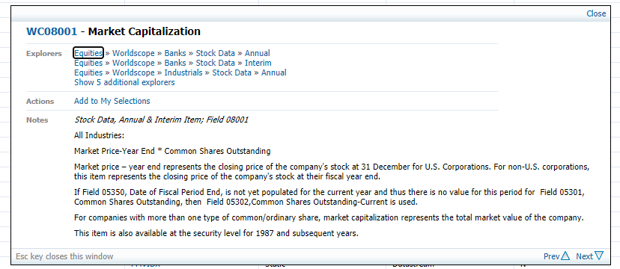

Data Definition of DataStream Data:

Monthly Market Value in Euro (in year prior) – Stocks

Variables that use this data:

* Comove as an unexplained premium, robustness tests, controlling with Fama and Macbeth regressions, Main Variables: Value, noted as ln(BTM).

Datatype: X(MVC)~E

Command: = DSGRID.(“LDJSTOXXMMYY”, “X(MVC)~E”, “startDate”, “endDate”, “M”, "RowHeader=true;TimeSeriesList=true;ColHeader=true;Transpose=true;DispSeriesDescription=false;YearlyTSFormat=false;QuarterlyTSFormat=false;Clearself=y;MonthlyTSFormat=True”)

* With MMYY the first month of each quarter, with the months ranging from 0102 until 0324.
* With startDate and endDate in YYYY-MM-DD format; startDate the first day of the year prior to MMYY and endDate the last day of two months after the MMYY. For example, for Jan 2002, 2001-01-01 and 2002-03-31.

Definition: This is the monetary value of total market value of the company. This includes equity (market capitalization), but also all other things in the company. Note that these are converted to euro and expressed in millions.

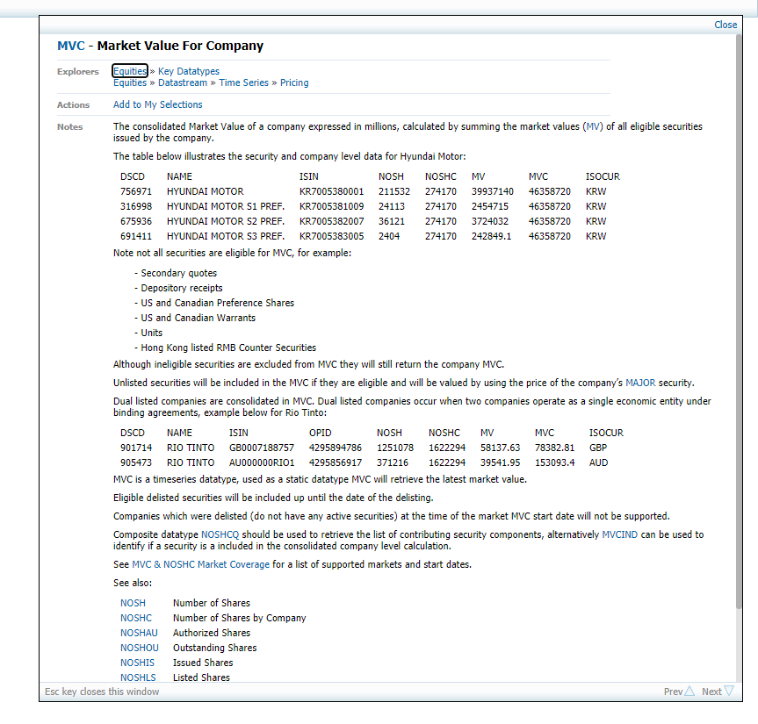

Data Definition of DataStream Data:

Monthly Common Equity in Euro (in year prior) – Stocks

Variables that use this data:

* Comove as an unexplained premium, robustness tests, controlling with Fama and Macbeth regressions, Main Variables: Value, noted as ln(BTM).

Datatype: X(WC03501)~E

Command: = DSGRID.(“LDJSTOXXMMYY”, “X(WC03501)~E”, “startDate”, “endDate”, “M”, "RowHeader=true;TimeSeriesList=true;ColHeader=true;Transpose=true;DispSeriesDescription=false;YearlyTSFormat=false;QuarterlyTSFormat=false;Clearself=y;MonthlyTSFormat=True”)

* With MMYY the first month of each quarter, with the months ranging from 0102 until 0324.
* With startDate and endDate in YYYY-MM-DD format; startDate the first day of the year prior to MMYY and endDate the last day of two months after the MMYY. For example, for Jan 2002, 2001-01-01 and 2002-03-31.

Definition: This is the amount that all common shareholders have invested in a company. Note that these are converted to euro.

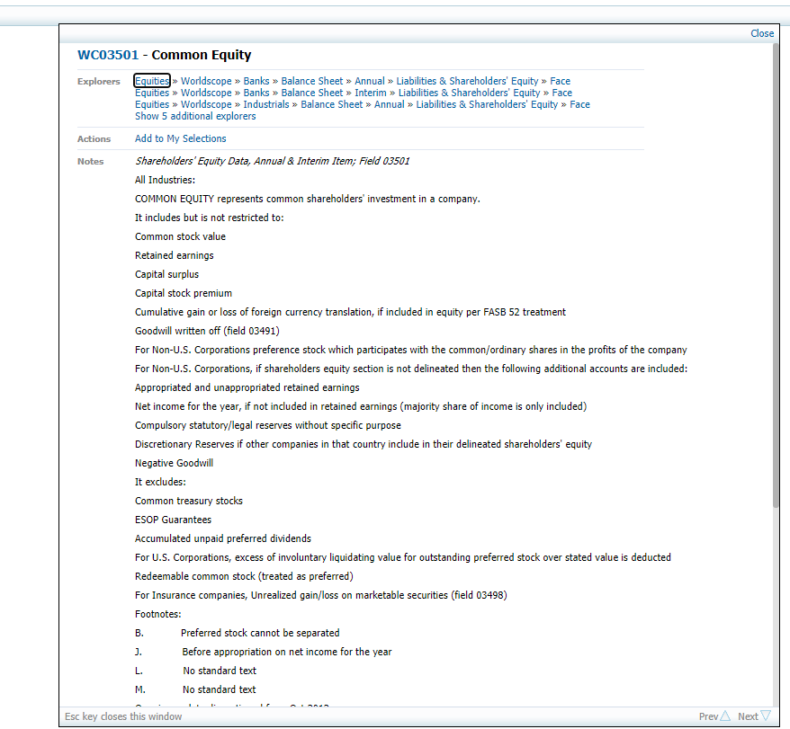

Data Definition of DataStream Data:

Daily Trading Volume in Euro (in 1 year prior) – Stocks

Variables that use this data:

* Comove as an unexplained premium, robustness tests, controlling with Fama and Macbeth regressions, other Measurements of Dependency and Volatility: Illiquidity Ratio, noted as Amihud.

Datatype: X(VA)~E

Command: = DSGRID.(“LDJSTOXXMMYY”, “X(VA)~E”, “startDate”, “endDate”, “D”, "RowHeader=true;TimeSeriesList=true;ColHeader=true;Transpose=true;DispSeriesDescription=false;YearlyTSFormat=false;QuarterlyTSFormat=false;Clearself=y;MonthlyTSFormat=True”)

* With MMYY the first month of each quarter, with the months ranging from 0102 until 0324.
* With startDate and endDate in YYYY-MM-DD format; startDate the first day of the year prior to MMYY and endDate the last day of two months after the MMYY. For example, for Jan 2002, 2001-01-01 and 2002-03-31.

Definition: This is the monetary value of the shares, bonds, etc. on that particular day. Note that these are converted to euro.

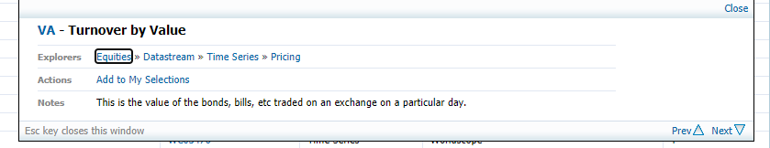

Data Definition of DataStream Data:

Monthly Turnover (in 2 months prior) – Stocks

Variables that use this data:

* Comove as an unexplained premium, robustness tests, controlling with Fama and Macbeth regressions, other Measurements of Dependency and Volatility: Turnover, noted as ln (turn).
* Comove as an unexplained premium, robustness tests, controlling with Fama and Macbeth regressions, other Measurements of Dependency and Volatility: Difference in Turnover, noted as Δ ln (turn).

Datatype: VO

Command: = DSGRID.(“LDJSTOXXMMYY”, “VO”, “startDate”, “endDate”, “M”, "RowHeader=true;TimeSeriesList=true;ColHeader=true;Transpose=true;DispSeriesDescription=false;YearlyTSFormat=false;QuarterlyTSFormat=false;Clearself=y;MonthlyTSFormat=True”)

* With MMYY the first month of each quarter, with the months ranging from 0102 until 0324.
* With startDate and endDate in YYYY-MM-DD format; startDate the first day of the two months prior to MMYY and endDate the last day of two months after the MMYY. For example, for Jan 2002, 2001-11-01 and 2002-03-31.

Definition: This is the number of shares sold in that month. Note that these are expressed in thousands.

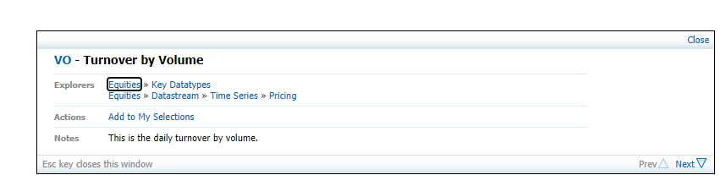

Data Definition of DataStream Data:

Monthly Operating Profitability in Euro (in year prior) – Stocks

Variables that use this data:

* Comove as an unexplained premium, robustness tests, controlling with Fama and Macbeth regressions, Other Benchmarks, Fixed Effects and Skipped Month: Operating Profitability, noted as Op. Profit..

Datatype: X(WC01250)~E

Command: = DSGRID.(“LDJSTOXXMMYY”, “X(WC01250)~E”, “startDate”, “endDate”, “M”, "RowHeader=true;TimeSeriesList=true;ColHeader=true;Transpose=true;DispSeriesDescription=false;YearlyTSFormat=false;QuarterlyTSFormat=false;Clearself=y;MonthlyTSFormat=True”)

* With MMYY the first month of each quarter, with the months ranging from 0102 until 0324.
* With startDate and endDate in YYYY-MM-DD format; startDate the first day of the year prior to MMYY and endDate the last day of two months after the MMYY. For example, for Jan 2002, 2001-01-01 and 2002-03-31.

Definition: This is the monetary value of the sales minus the operating expenses. Note that these are converted to euro.

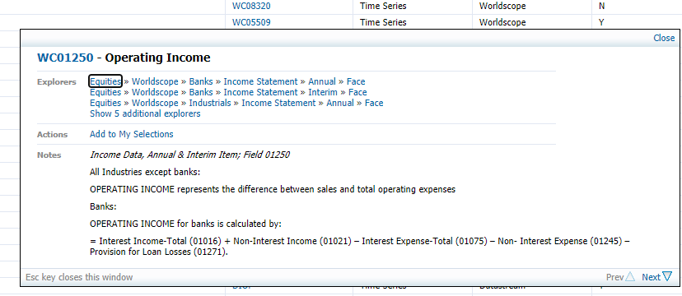

Data Definition of DataStream Data:

Monthly Total Assets in Euro (in year prior) – Stocks

Variables that use this data:

* Comove as an unexplained premium, robustness tests, controlling with Fama and Macbeth regressions, Other Benchmarks, Fixed Effects and Skipped Month: Investment, noted as Asset Growth.

Datatype: X(WC02999)~E

Command: = DSGRID.(“LDJSTOXXMMYY”, “X(WC02999)~E”, “startDate”, “endDate”, “M”, "RowHeader=true;TimeSeriesList=true;ColHeader=true;Transpose=true;DispSeriesDescription=false;YearlyTSFormat=false;QuarterlyTSFormat=false;Clearself=y;MonthlyTSFormat=True”)

* With MMYY the first month of each quarter, with the months ranging from 0102 until 0324.
* With startDate and endDate in YYYY-MM-DD format; startDate the first day of the month that occurs before the year prior to MMYY and endDate the last day of two months after the MMYY. For example, for Jan 2002, 2000-12-01 and 2002-03-31.

Definition: This is the monetary value of the total assets of the company. Note that these are converted to euro.

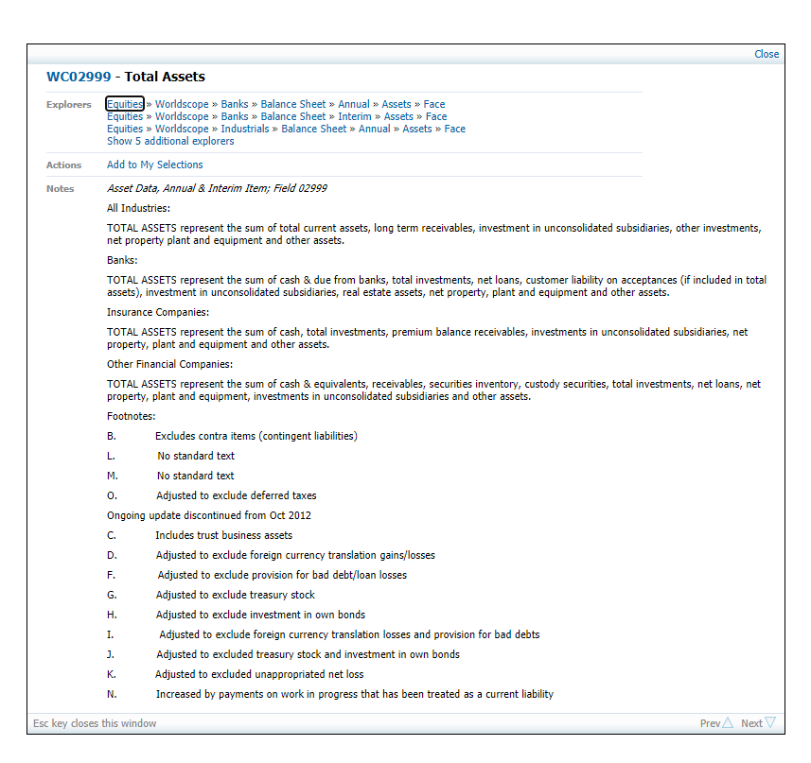

Data Definition of DataStream Data:

Industry – Stocks

Variables that use this data:

* Comove as an unexplained premium, robustness tests, controlling with Fama and Macbeth regressions, Other Benchmarks, Fixed Effects and Skipped Month: Fixed Industry Effects, with dummy variables.

Datatype: INDM

Command: =DSGRID("LDJSTOXXMMYY","NAME;INDM","Latest Value","","","RowHeader=true;ColHeader=true;Transpose=true;DispSeriesDescription=false;DispDatatypeDescription=false;Clearself=y”)

* With MMYY the first month of each quarter, with the months ranging from 0102 until 0324.

Definition: This is the name of the industry the company is active in.

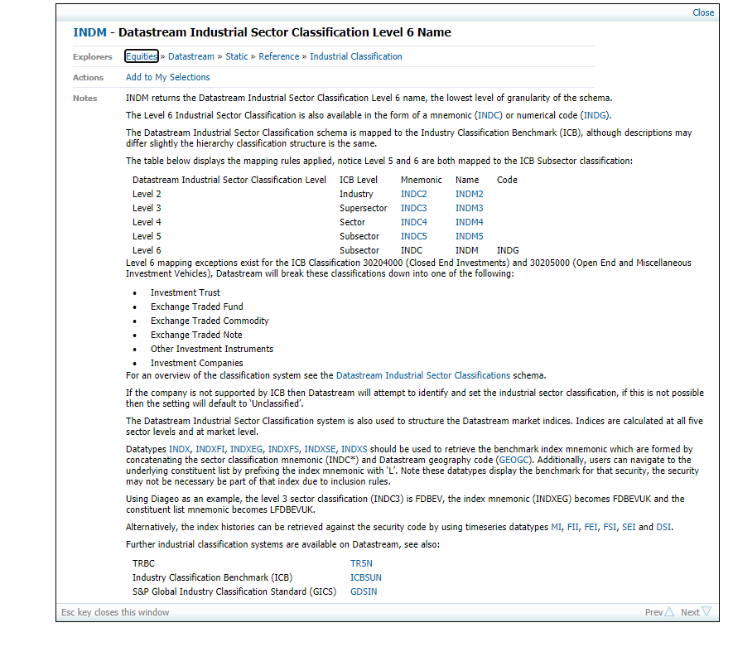

Data Definition of DataStream Data:

Exchange – Stocks

Variables that use this data:

* Comove as an unexplained premium, robustness tests, controlling with Fama and Macbeth regressions, Other Benchmarks, Fixed Effects and Skipped Month: Fixed Exchange Effects, with dummy variables.
* Comove as an unexplained premium, robustness tests, controlling with Fama and Macbeth regressions, Varying the Comove Measure and the Sample: Excluding certain Exchanges from the sample.

Datatype: EXDSCD

Command: =DSGRID("LDJSTOXXMMYY","NAME;EXDSCD","Latest Value","","","RowHeader=true;ColHeader=true;Transpose=true;DispSeriesDescription=false;DispDatatypeDescription=false;Clearself=y”)

* With MMYY the first month of each quarter, with the months ranging from 0102 until 0324.

Definition: This is the name of the stock exchange the company is listed on.

